***Darker than Black***

With the news from Riverdeep hanging heavily on the minds of the party, the sailors aboard the Agile lifted its anchors from the cold water off Mazica. The adventurers knew that they were too far now to return to the aid of the Earl to the south. They had to keep pushing east to Northwatch.

As the ship set off, Ander sent a telepathic message to the captain of the Ebon Wing, which was restocking at the Jotungard fortresses, informing him of their departure. The Ebon Wing would meet the party in Kells. The road to Kells would not be an easy one, though…

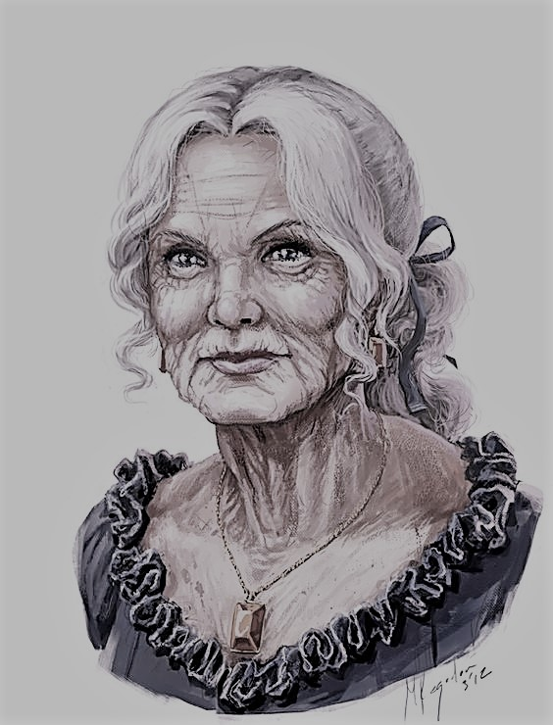

Rohme Reynelis spoke softly as she set out her proposal: “The waters of the north coast are icy and treacherous. It may be in our best interests to leave the ship on the beach east of the Jotungard fortresses and continue on foot to Kells.” The group unanimously agreed to follow the old woman’s advice, and so their fate was set.

The crossing from Mazica to the wasteful north coast of Wintercrown took the Agile ten days, and the party was relieved when they were finally able to touch land again—despite the land being barely less hostile than the waters. As the sailors and adventurers set up their camp, Fiora and Flame went scouting for food. The ranger, bundled in her thick furs, stalked the coast for hours—but neither her black jaguar nor her found the slightest evidence of life—her search was not in vain, however. Hanging in the sky to the west was a bright, ghostly light. Brighter than any star in the night, yet hazy and ethereal. It dug into Fiora’s mind—it was out of place. The mountains in the distance seemed too close, and the wind too cold. Something was amiss.

The group broke camp before dawn the next day and began their trek to Kells. The journey was slow, and many of the sailors’ died, one by one, on the way. Twenty days of endless snow and wind passed before the horizon offered any solace to the adventurers—a forest. Fiora scouted ahead, finding the trees tall and frozen. The forest was not deep, though, as it bordered a massive ravine stretching northeast from the mountains to southwest as far as the eye could see. The depths of the ravine were clouded by a thick fog that seemed illuminated by some faint light within it, and it was bridged only by a towering cathedral. The building stood like an arch across the ravine, with its edges supported by massive towers and its center a rotunda of dark stone. The cathedral’s towers and gate were carved of massive black stones, and its entrance seemed non-existent. As the party grouped in front of the structure, they saw the outlines of three archways carved into the stone. An iced over pool sunk calmly into the snow before the carvings, and in it the reflections of the doorways were open, casting out a calm yellow candlelight. The puzzle was set, and the group wondered at it for a good time.



***The Frozen Coast of Wintercrown***

After breaking through the ice and falling into the enchanted water of the pool, the party finally uncovered the secret to the cathedral’s entrance. In the style of smooth criminals, they entered the dark temple and slaughtered the cannibalistic cultists that met them in less than six seconds. Before the cultists died, however, they made it known to whom they served: the Defiler. Master of the Hunter, destroyer of the Mistwalkers, and apparent plague to the adventurers.

The halls of the bridge were filled with the bones of men, elves, dwarves, and many other creatures that the cultists had devoured. Twisting hallways branched from the main leading to unlit rooms decorated only by lines and stacks of unsealed sarcophagi. The dusty rooms held no signs of life, but were overpowered by the empty smell of death. The doors to the main rotunda of the cathedral were of heavy wood, but they pushed open quietly and smoothly. The party entered quietly, observing the scene:

The room was cold, with balconies open to the winds of the north on each of its sides. A faint glowing line ran through the room, through what would be the center of the ravine outside. Half of the room was raised, and four small lines of stairs bridged the halves. At the center of the room, reaching out form the raised stage was an arching stone podium. Centered on the raised portion of the rotunda was a dais carved into the stone. The inscription was complex and vile, with channels sloping inward from its edges. At the center of the dais stood a tall statue, a woman in shape but faceless and with an open ribcage and outstretched hands ending in claws of black marble. Seven cultists encircled it, four kneeling while the other three stood and chanted around it. One stepped away from the dais, moving to the podium and calling out to the adventurers,

*“To the realm of the Lord of Immortality, the One of Endless Love, our dark god, have you come. Here we devour for him, create for him his army.*

*For him we live and die.*

*We give our bones to him in willingness, to his aspect, the Devourer of Souls, Lyga.”*

Raime wasted no time in stepping through the shadows, appearing behind the speaking cultist and jabbing his soul-stealing claws into the cultist’s spine. As blood ran from the corners of the cultist’s mouth, he pointed a long finger at Rohme Reynleis: “Come.”

The old woman vanished and reappeared in front of the tall stone statue. A bolt of lightning erupted from her finger and smote down the four kneeling cultists, their flesh bursting and melting, their blood flowing into the channels of the dais.

The wizard Moog clapped his hands together and teleported onto the raised stage, but as he did so he heard the voices in his head, given to him by the Tree of Selor in Mazica, speak to him: “Stop. Stop. Stop, stop, stop. Stop. STOP. STOP, STOP, STOP! STOP—“ But as he crossed the glowing white line across the center of the room the voices became quiet, replaced by a soft laughter.

Ander and Kyrat both ran up the stairs onto the stone stage and engaged the cultist nearest to Rohme. As they crossed the room’s center, their heads too were filled with a sickening laughter.

The blood of the dead cultists pooled at the feet of the statue, and as Rohme kneeled in front of it, red tendrils rose from the pool and snaked up the legs, the body, the neck of the statue. Rivulets of blood flowed down its arms, dripping from its outstretched fingers. The stone of the statue cracked and slewed off like burned flesh from a corpse, and underneath there was the dead aspect, covered in pale, rotting flesh. As the stone fell onto the dais, the being shuddered, its open ribcage extending as if breath still filled it. The face of the monster was blank but for a wide, red mouth—and it smiled as it stepped from its prison. Its eyeless face turned down to Rohme, kneeling at its feet.

“Alluna, I thank you for granting me life once again. I shall serve you and our wondrous lord once again!” The monster moved forward past Rohme lithely, as if no weight bore upon its rotting feet.

“I am Lyga the Devourer, and I claim your souls for my master. Come to me and feel the maddening light of the stars and the teeth of the darkness! Come to me and die!”

Lyga seemed to freeze then as Rohme raised her hands and jerked them backwards, ripping the bones from the bodies of the cultists and forming them into an armor-like cage around her. As she sank back to her knees Lyga seemed revitalized, and she smiled, baring her hundreds of needle-like teeth. Saliva dripped from her lips, running down her chin and dripping on her exposed, pulsing ribs.

*Raime.*

*Rohme.*

*Rovald.*

*Zan.*

*Fiora.*

*Theon.*

*Abel.*

*Ander.*

*Kyrat.*

*Moog.*

Ten there were that stood then and fought with Lyga the Devourer. Six left as they came.

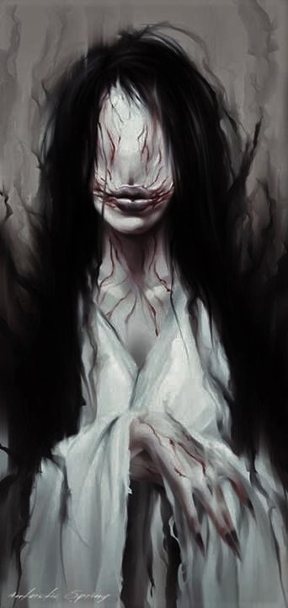

As Rohme, called Alluna by Lyga, kneeled in her bone cage, the age seemed to melt off her like an illusion to an enlightened mind. He wrinkles disappeared, her hair grew long and smooth, and her body youthened. Power coursed from her fingers, but she stayed within the bones. Lyga’s claws were sharp as adamantine blades, but the attacks of the adventurers were swift and unrelenting. Kyrat held the offensive with Rovald, both dealing consistent blows. Kyrat’s holy greatsword shone in the chamber as they cut into Lyga’s undead fiendish flesh. Raime summoned forth two concentric illusionary spheres, the outer of perforated darkness, the other of dazzling light, and he spun them above the combat. The shadows danced and cascaded around the room, mixing and mingling with the soft moonlight from the balconies. The monk stepped through the shadows, using his mobility to take advantage of Lyga.

Fiora and Theon filled Lyga with arrows and thorns from afar, and Abel’s eldritch blast seared her body. Moog created the incarnation of Lyga’s deepest fears and beset it upon her, for even those most evil can feel fear. Though he knew not what the illusion showed, he used his mastery of dreams to shape the illusion into a sphere around her, cutting off any movement. Ander unraveled his whip and supported his fellow adventurers—but Lyga’s anger knew no bounds. She took the body of a nearby cultist into her gaping chest, and the black fluid began to dissolve the corpse and absorb it into her flesh. She took the body of another and melded it into her own, regaining strength. She dug her claws into the melting corpse in her chest and pried her ribs apart, unleashing a burst of necrotic energy in a whirlwind around her. The tearing energy rent the souls of all nearby, sending many into unconsciousness.

Moog’s illusion fell to Lyga’s rejuvenated mind, and hope seemed lost as Kyrat fell to his knees, Flametongue clanging on the cold stones. Rovald’s blood covered the stones, his chest ripped by Lyga’s claws, barely shuddering breaths as he lay next to Kyrat.

The conscious struggled on, but they found that Lyga was not their only problem: as Ander and Fiora stood too long in the moonlight past the white line at the center of the room, the laughter in their heads became louder—overwhelming. The raucous noise beat into Ander’s head, deafening, blinding, painful. Fiora felt the same—but her will bent to the laughter, and soon it brought her to her knees.

The fight was far from over. From the dancing shadows behind Lyga leapt Raime. He dug his right clawed gauntlet deep into Lyga’s thigh, then his left into the same. Silently, he called upon the souls trapped within the Husk of Habbakuk on his weapons and released a shearing blade of energy into Lyga’s leg, severing it. The monster fell to the ground screaming, and in her anger she flung her razor-like claws at Raime, drawing him from the throat to his thighs. She grabbed the dying monk and brought him close—placing him softly within her ribcage.

With his illusion fallen, Moog was free to move to the front lines. His eyes glowed with a blinding green as he grew, transforming into a massive prehistoric creature. He lumbered forward and clamped his jaws around Lyga’s other leg. As he clenched his jaws closed, Ander managed to bring Kyrat back to consciousness. The dragonborn wasted no time to grab Flametongue and run up the back of Moog in his monstrous form. Kyrat jumped from Moog’s head and brought his broadsword down on Lyga’s face, marring her flat, pale face with a massive red gash. Fiora stood, then, but her eyes were crazed and cursed. She drew her bow and fired an arrow—but not at Lyga. The shaft flew and pierced Kyrat’s shoulder blade. Seeing Fiora’s apparent betrayal, Zan moved and cast a constricting spell on the ranger, holding her in place.

Moog jerked his head back and ripped Lyga’s other leg from her body. The undead monster screamed again, her cries ripping at the ears of all around. Black-red blood oozed from her stumps, but she pushed through the pain. In a final push of her power, she took Raime’s body in her chest and let loose a surge of necrotic energy once again. The monk was absorbed into the creature’s flesh, gone. The necrotic wave knocked Kyrat and Ander into unconsciousness, but Moog stood through it. Staggering, he moved forward to bite Lyga’s face—but she was quick, and jabbed upwards with her claws, ripping into the soft underbelly of Moog’s form. It was Abel’s eldritch blast and Theon’s arrows that took Lyga to death then, her claws still inside Moog. As she died, Moog lost his form and fell backward, away from the corpse.

The room was quiet, but for the dripping of blood onto the stones and the ragged breathing of those nearing death. Then Rohme laughed softly, and stood in her prison of bones. The cage parted before her, and she walked out in her youthened state.

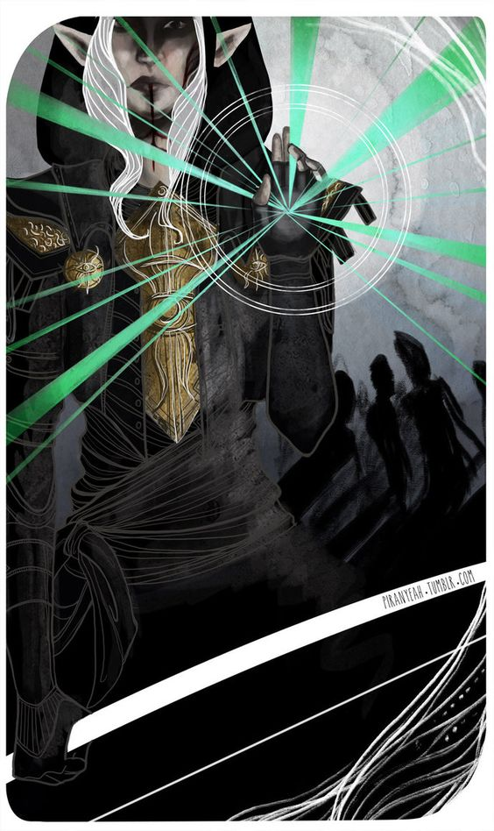

***Alluna***

*“Let the dead be the first to feel his gift.”*

She raised her hand, and shadows spilled from her palm, winding their way across the flagstones and into the open chest of Lyga. The corpse pulsed with energy—but it was not Lyga that felt life again. A single hand burst from the flesh of Lyga, then another garbed in a clawed gauntlet. Raime, dead but living, stood in the black fluid of Lyga. He looked at those standing around him: at Moog, lying weak on the ground, but not dead. At the body of Rovald, bleeding next to him. At Kyrat and Ander, both unconscious nearby.

Zan thought quickly, and released Fiora from her bonds to aid Kyrat. She gave the dragon a burst of life, but it was only temporary. His eyelids flickered open, and upon hearing Zan’s message in his mind, he rolled away and grabbed the body of Ander, bringing them away from Alluna and Raime.

Moog teleported quickly away as Abel unleashed a mighty fireball upon the undead before him—but the monk’s abilities were uncanny, and he dodged the blast. The fires scorched Alluna, though, and her anger surged. She glanced at Raime, and compelled him to action. Raime walked slowly to Rovald, lying on the cold stones in a pool of his own and Lyga’s thick blood. Mercilessly, Raime gored the dying mercenary, ripping him apart with his claws. Zan screamed as she saw her friend slaughtered on the stones, but she was unable to do anything—Alluna stepped forward and placed a hand on Raime and the body of Rovald, and was gone, vanished into the air of the night.

It was over. Those surviving quickly tied Fiora down as she writhed against them. She was cursed by the laughter of the moonlight, unable to see reason or truth.

*Raime, killed.*

*Rovald, killed.*

*Rohme, betrayer.*

*Fiora, cursed.*

The clouds passed in front of the moon.

And so they slept, in the shadows darker than black.